Latihan MySQL 2

**NAMA:**Muhammad Aqif Addin Bin Malik

1)Create Database Hospital.



2)show databases

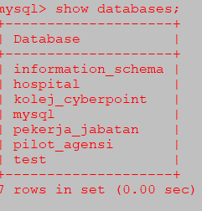

3)use database hospital.



4)create table medication.

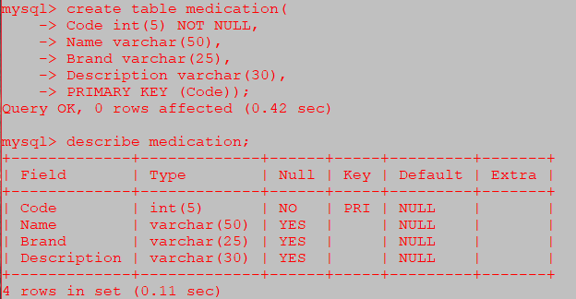

5)create table nurse.  
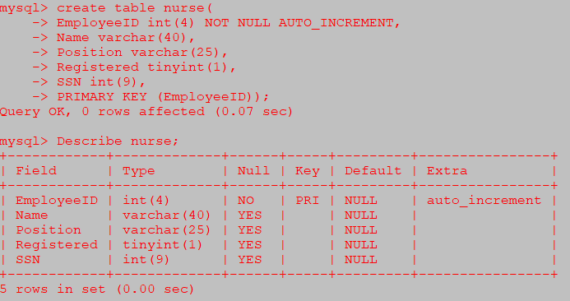

6)create table appointment.

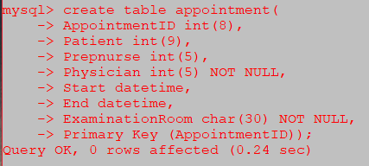

7)create table prescription

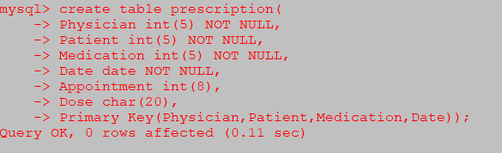

8)create table physician

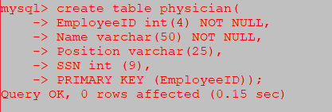

9)insert maklumat dalam table physician



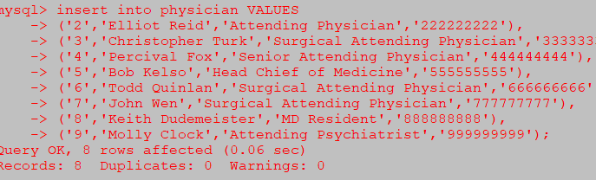

10)create table department.

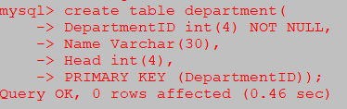

11)insert maklumat dalam table department

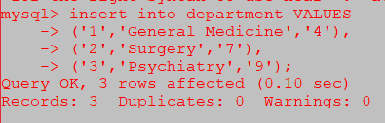

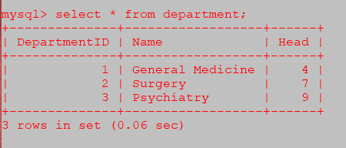

12)create table patient

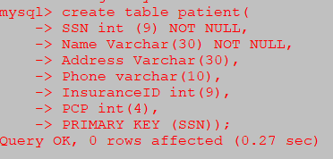

13)insert into maklumat patient

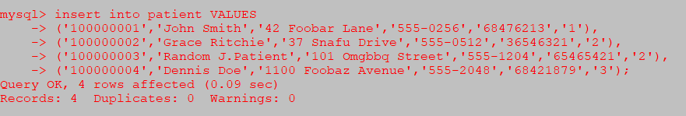

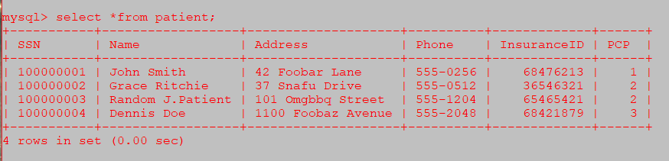

14)insert into maklumat medication.

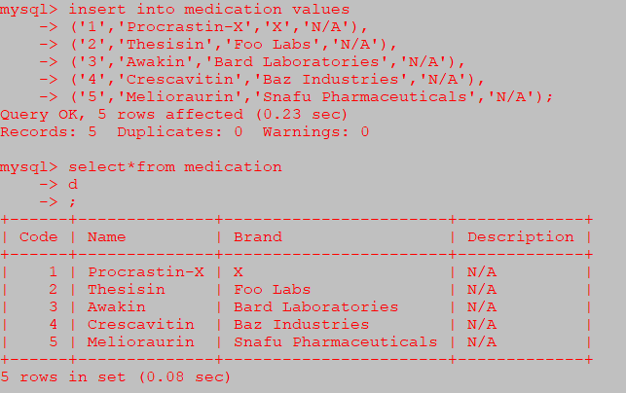

15)Insert maklumat into Nurse

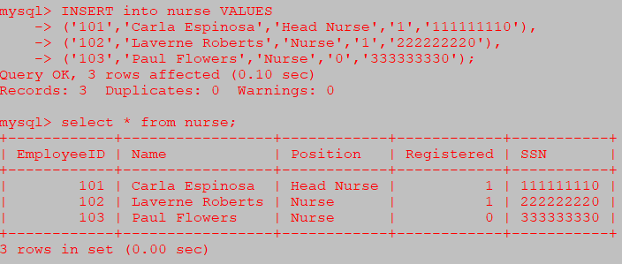

16)Insert Into Maklumat into Appointment

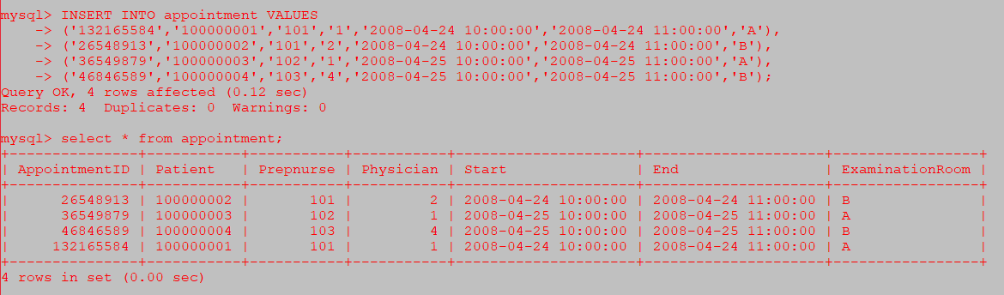

17)insert into maklumat prescription

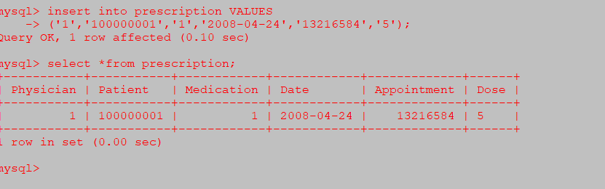

18)Describe Table_Name

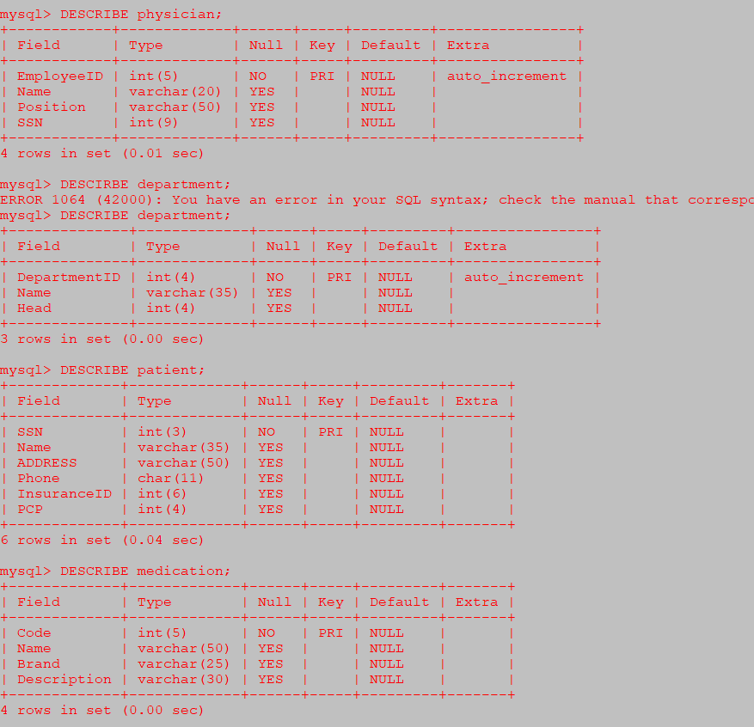

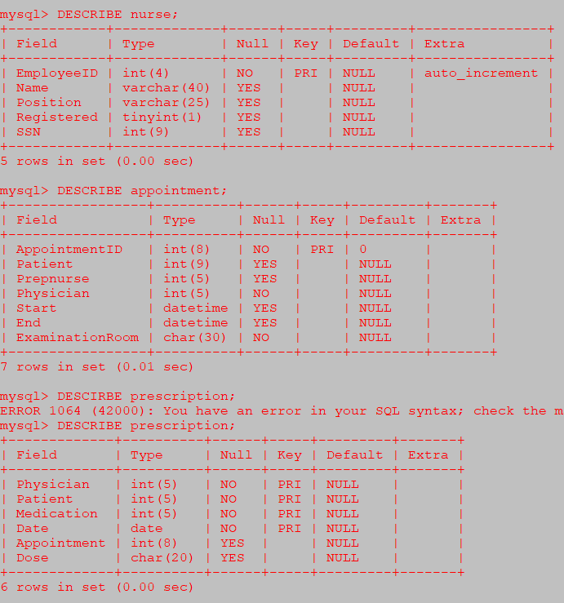

19)Delete Data Molly Clock dalam Jadual Physician

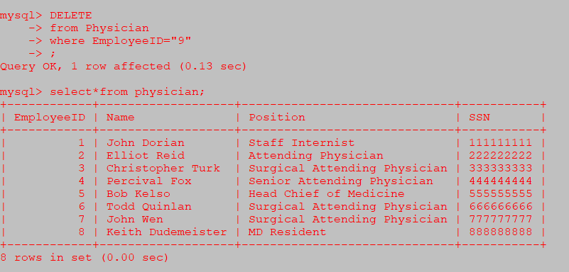

20)Tukar data type Brand Varchar (25) ke Varchar (50) dalam jadual medication.

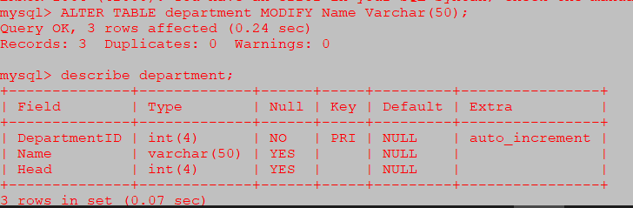

21)Tukar Nama Thesisin kepada Brand Food lab dalam jadual medication

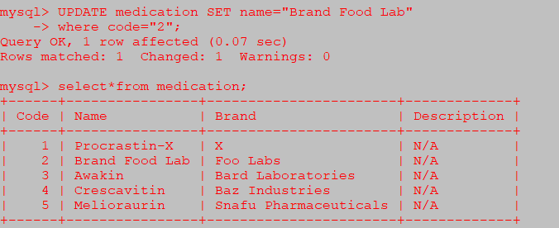

22)Tambah column Jantina dalam jadual patient

